**Chapter 4 - Cell Cycle**

**All Lectures Uploaded on YouTube:**

[**https://tinyurl.com/fkm9-biology**](https://tinyurl.com/fkm9-biology)

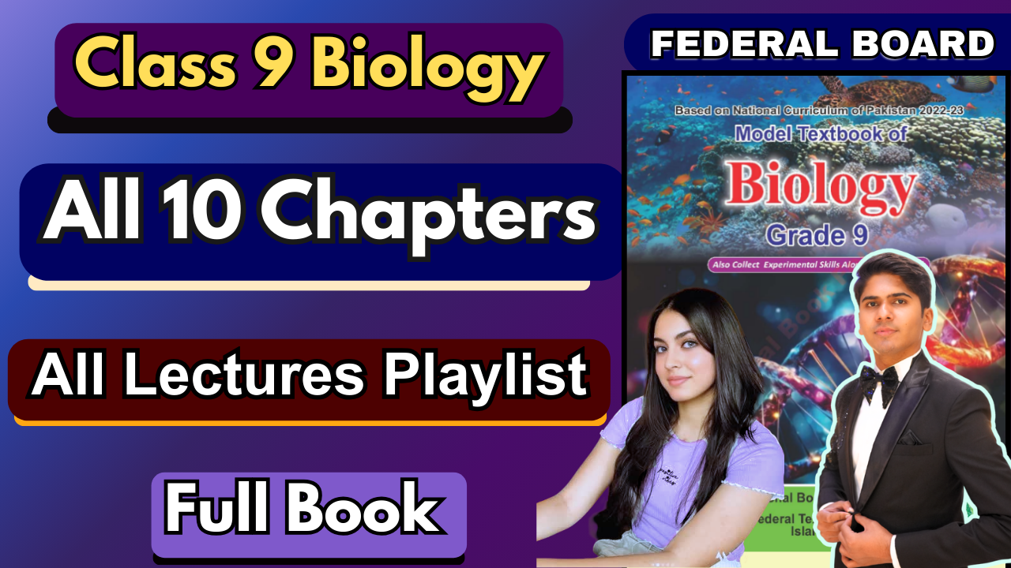

#### The process of cell division is needed of development, growth, healing and for sexual and asexual reproduction. Cell not only increase in number but also manage to transfer genetic characteristics to the next generations. During cell cycle, cells grow in size, form new molecules and organelles, replicate their chromosomes and divide by equally distributing genetic material in the daughter cell.

#### **4.1. Cell Cycle**

#### The cell cycle is a sequence of events where a cell grows, replicates its genetic material (**genome**), and divides into two daughter cells. It consists of two main phases; interphase and mitotic phase.

These two newly formed daughter cells are identical and each can perform its own cell cycle and complete cell division on its own.

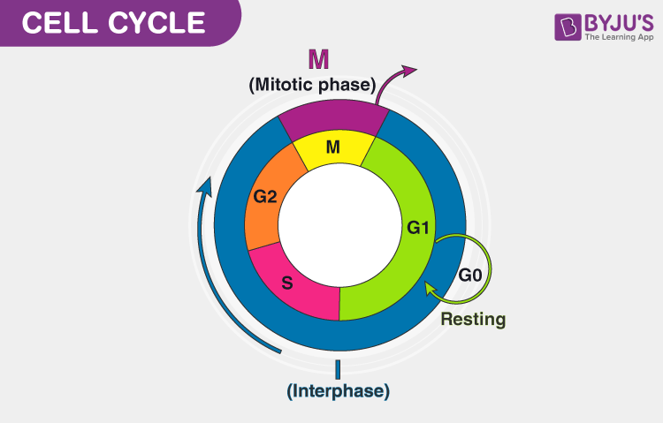

**Phases of Cell Cycle:**

* A cell cycle is divided into two phases; **interphase** and **mitotic** phase.
* **Interphase** is the phase between two consecutive cell divisions where the cell is NOT dividing and continues with normal cell functions.
* Interphase is not part of mitosis, it happens before mitosis
* This stage is further divided into three sub-phases, G1 phase, S phase, and G2 phase

1. **G1 phase:** G1 is Gap 1 phase of interphase. The cell grows, produces organelles, and prepares proteins for DNA replication, which is the next phase (synthesis). The enzymes and nucleotides required for the replication process are produced in this stage.
2. **S phase:** DNA synthesis occurs and the cell replicates its DNA to form two copies of each chromosome.
3. **G2 phase:** The cell prepares for mitosis, producing proteins which are required to form spindle fibres. More mitochondria are formed, accumulating energy for cell division.
4. **G0 phase:** the resting phase of the cell cycle where the cell stops dividing. They carry out their normal functions in this phase but don't divide further.

* **M Phase (Mitotic Phase):** The cell divides into two identical daughter cells from a single parent cell. This phase is critical for the growth and healing of normal body cells. Since the DNA is identical, there is no variation.

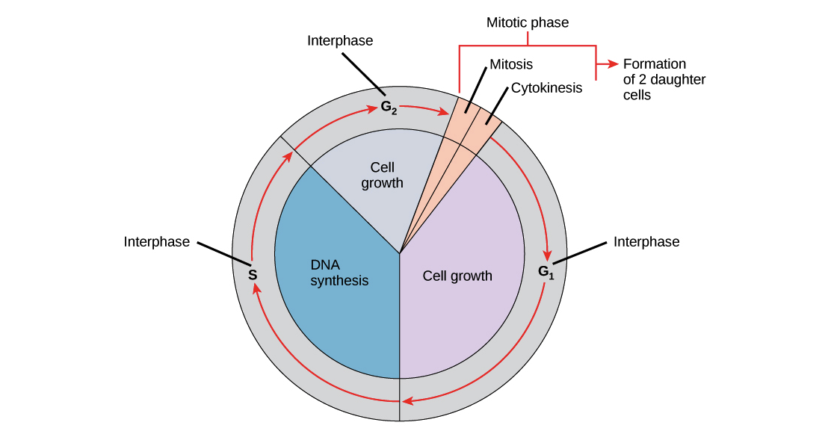

#### **4.2 Spindle Apparatus**

* The spindle apparatus is a cytoskeletal structure comprising microtubules that help separate the chromatids or the duplicated chromosomes from the centre of the cell to the opposite poles so that each daughter nucleus can get an equal number of genetic material.
* The spindle apparatus separates chromosomes during cell division and moves them to opposite poles.
* In **animal cells,** a pair of centrioles near the nucleus duplicates and moves to opposite poles, forming spindle fibres.
* In **plant cells,** the spindle apparatus forms without centrioles.

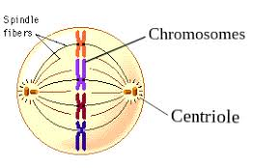

#### **4.3 Mitosis**

* **Definition:** Process where one parent cell divides to form two genetically identical daughter cells with the same number of chromosomes.
* **Stages of Mitosis:**

**Karyokinesis** is the process of nuclear division during cell division, where the nucleus of a cell divides to form two nuclei.

1. **Prophase:** Chromatin condenses to form tightly coiled chromosomes, and spindle apparatus forms. The nucleolus and nuclear envelope disappear.

*All these steps in prophase are essential for the next phases to go smoothly, as the cell is well prepared for division.

1. **Metaphase:** Chromosomes align at the equator (middle) of the spindle fibres so that they can be easily divided in half in the next stage.
2. **Anaphase:** Spindle fibres pull chromatids to opposite poles.
3. **Telophase:** Chromatids reach the poles and the nuclear membrane reforms. Chromatids uncoil themselves and form chromatin fibres. The spindle apparatus disintegrates.

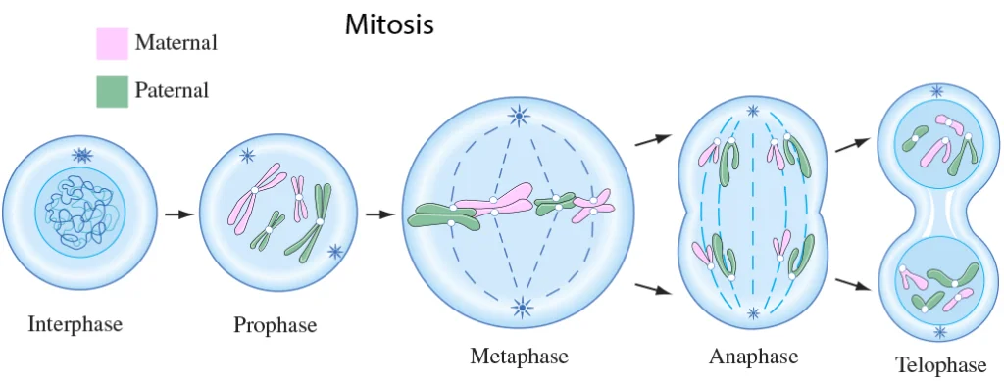

**Cytokinesis:** the cytoplasm of the parent cell divides into two resulting in separate daughter cells. It starts in the final stage of mitosis; telophase, and continues even after.

*In plant cell spindle fibres in the equator region form a structure called phragmoplast. Golgi apparatus forms vesicles which appear in the centre of phragmoplast initially and then grow at equatorial plane.

* **Animal vs. Plant Cells:**
  + **Animal Cell Cytokinesis:** Formation of a cleavage furrow that pinches the cell in two.
  + **Plant Cell Cytokinesis:** Formation of a cell plate that develops into a partition.

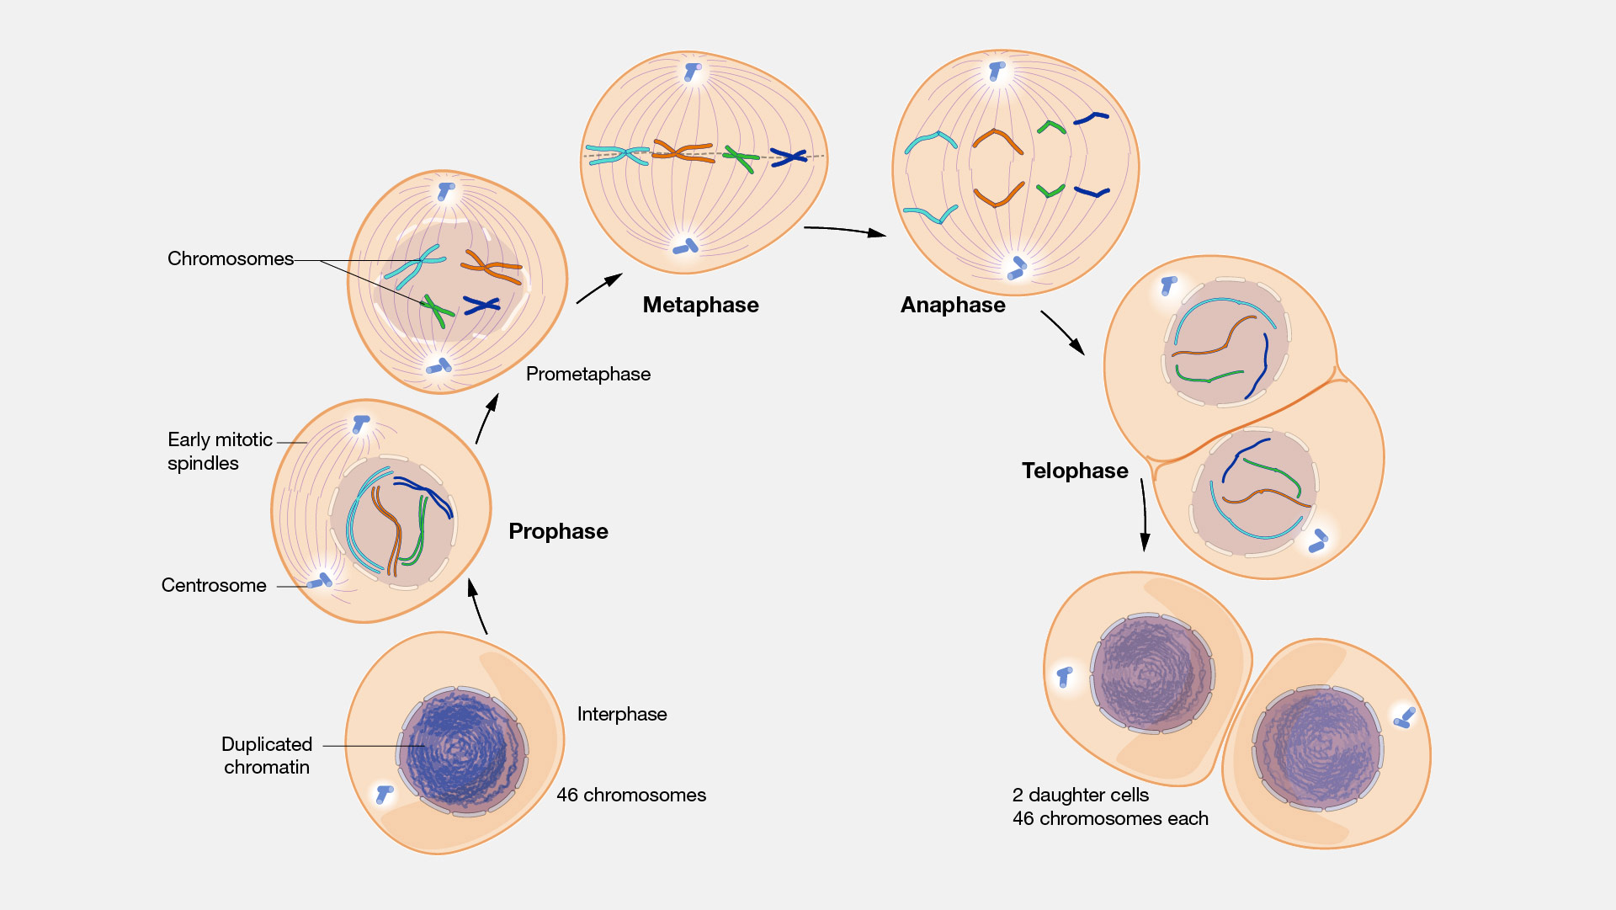

#### **4.3.1. Significance of Mitosis:**

* **Genetic Stability:** Daughter cells have the same genetic information and an equal number of chromosomes as the parent cell.
* **Development and Growth:** Essential for the growth of multicellular organisms. Continuous mitosis helps in the growth and development of an individual, increasing the number of cells as you grow
* **Cell Replacement and Wound Healing:** This procedure replaces worn-out cells, especially in the skin, digestive tract, and respiratory tract.
* **Regeneration:** Some animals can regenerate body parts (e.g., sea stars, earthworms) if damaged or removed accidentally.
* **Asexual reproduction:** it is a type of reproduction in which offspring are produced from a single parent. Mitosis ensures the generation of genetically identical offspring (clones of the parent) by duplicating the parent cell's DNA and dividing it equally into two daughter cells.
* **Cloning or tissue culture:** Cloning uses mitotic cell division to replicate an organism's genetic material in very large quantities, usually for industrial or therapeutic purposes. For example, in the medicinal field, growing tissues is used for research, therapy, or regenerative purposes.

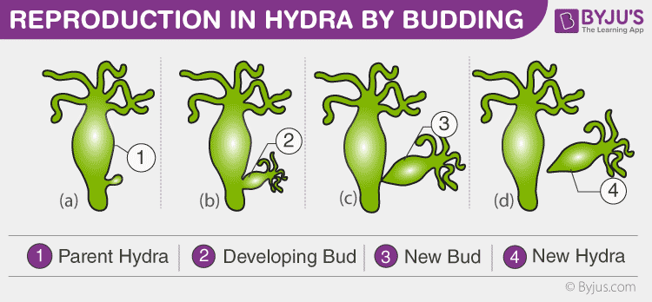

**4.5. Meiosis**

* **Meiosis** is a type of cell division that reduces the chromosome number by half, resulting in four genetically unique haploid daughter cells.
* Haploid refers to the cell having one set of chromosomes i.e. one copy of each chromosome (23) while diploid cells have two sets (46 chromosomes)

Haploid = n, Diploid = 2n

* Meiosis only produces gametes, genetically different haploid cells (egg or sperm)
* Therefore, it is essential for sexual reproduction.
* Meiosis takes place in the form of two divisions; Meiosis 1 and Meiosis 2.

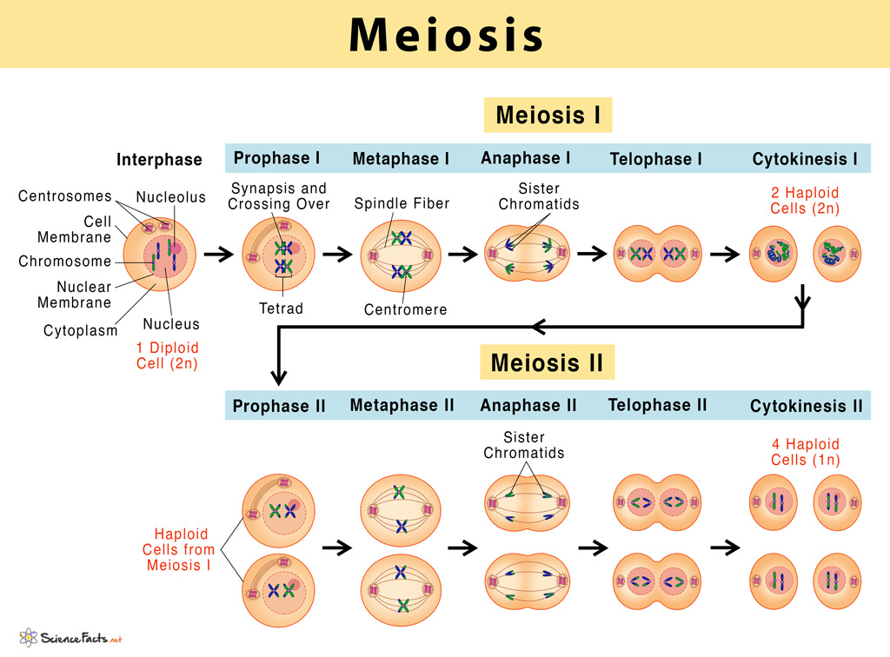

**Meiosis 1: Reduction division**

* This phase is called the reduction division as the daughter cell reduces the number of chromosomes in half. (haploid)
* Karyokinesis forms two haploid nuclei followed by cytokinesis.
* It also has the same stages as mitosis: Prophase 1, Metaphase 1, Anaphase 1, Telophase 1

**Prophase 1:**

* Chromosomes become more visible as the chromatin condenses and coils together.
* Homologous chromosomes pair up, aligning point-to-point to form **bivalents**.
* **Crossing Over** happens; non-sister chromatids of homologous chromosomes exchange genetic material at **chiasmata**. This leads to genetic variation.
* Nucleoli and nuclear envelope disappear.
* The spindle apparatus starts forming.

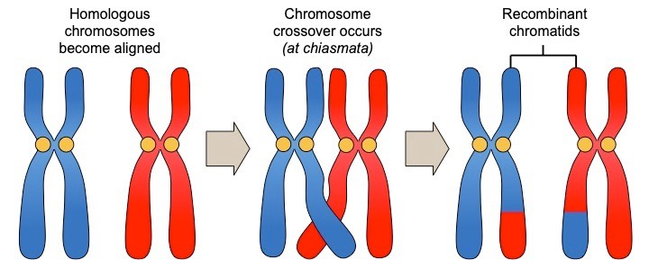

**Metaphase 1:**

* Homologous pairs of chromosomes (bivalents) align at the middle (equatorial plate)
* Spindle fibres attach to the centromeres of each chromosome.
* Each homologous chromosome in the pair is connected to spindle fibres from one pole, ensuring they are pulled apart correctly in the next phase.

**Anaphase 1:**

* Spindle fibres pull homologous chromosomes to opposite poles.
* Sister chromatids remain attached at the centromere.

**Telophase 1:**

* Chromosomes uncoil into chromatin.
* A nuclear envelope forms around each set of chromosomes at the poles.
* Two haploid nuclei are formed, each containing one chromosome from each homologous pair.

#### **Cytokinesis I:**

* Division of cytoplasm occurs:
  + Results in **two haploid cells**.
  + Chromosomes consist of two chromatids (not genetically identical due to crossing over).

**Meiosis II:**

**\*Interphase 2** does not involve any DNA replication but only prepares itself for the next phase of meiotic division.

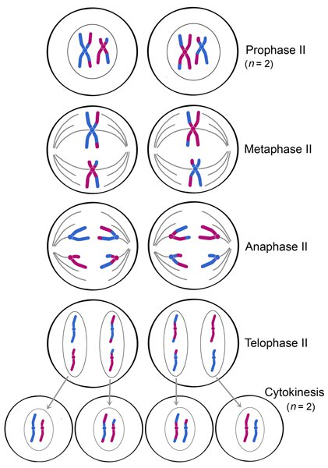

#### **Prophase II:**

* Chromosomes condense again.
* The spindle apparatus forms and the nuclear envelope disintegrates.

#### **Metaphase II:**

* Chromosomes align at the equatorial plate.
* Spindle fibres attach to the centromere of each chromosome.

#### **Anaphase II:**

* Centromeres split, separating the sister chromatids.
* Chromatids (now individual chromosomes) are pulled to opposite poles.

#### **Telophase II:**

* Chromosomes uncoil at the poles, reverting to chromatin.
* The nuclear envelope reforms around each chromosome set.

#### **Cytokinesis II:**

* Cytoplasm divides to form **four haploid daughter cells**.
* Each cell has half the chromosome number of the original parent cell and is genetically unique.

### **Significance of Meiosis:**

1. **Maintenance of Chromosome Number**: Ensures the same chromosome number is maintained across generations in sexually reproducing organisms.
2. **Genetic Variation**:
   * Crossing over in prophase I leads to genetic recombination.
   * Independent assortment during metaphase I contribute to diverse genetic combinations.
3. **Formation of Gametes**:
   * Haploid cells (gametes) are necessary for sexual reproduction.
   * Fusion of gametes restores the diploid number in the zygote.

